|  |  |
| --- | --- |
| EXERCICES | POINTS |
| Exercise 1 | 10 |
| Exercise 2 | 10 |
| Exercise 3 | 30 |
| Exercise 4 | 50 |
| **TOTAL** | **100** |

**Exercise 1: Boolean expression**

Demonstrate these equalities using the 7 simplification rules you have learnt.

1. (A or B or C) and (!A or B or C) = B or C

((A or (B or C) and (!A or (B or C)) = B or C

1. (A and B) or (!A or !B) = True

A or fales = true

**Exercise 2: Truth table**

1. **A and (A or B)**

|  |  |  |
| --- | --- | --- |
| **A** | **B** | **A and (A or B)** |
| True | True | true |
| True | False | true |
| False | True | fales |
| False | False | fales |

A and (A or B) = true and (true or fales)= true

1. **(A and B) or !C or [C and (!A or !B)]**

|  |  |  |  |
| --- | --- | --- | --- |
| **A** | **B** | **C** | **(A and B) or !C or [C and (!A or !B)]** |
| True | True | True | true |
| True | True | False | true |
| True | False | True | fales |
| True | False | False | true |
| False | True | True | true |
| False | True | False | true |
| False | False | True | true |
| False | False | False | true |

(A and B) or !C or [C and (!A or !B)]= (true and true) or !true or [true and (true or !true) = true or !true or true = true

**Exercise 3: Ranges**

1. **Simplify** the expressions
2. a < 3 or a > 3

0 1 2 3 4 5 6 7 8 9 10 11 12 13 14 15 16 17

1. a >5 or a < 6

0 1 2 3 4 5 6 7 8 9 10 11 12 13 14 15 16 17

1. a > 2 and a > 12

0 1 2 3 4 5 6 7 8 9 10 11 12 13 14 15 16 17

1. a >= 8 or a > 8

0 1 2 3 4 5 6 7 8 9 10 11 12 13 14 15 16 17

1. a >=0 and a <= 0

0 1 2 3 4 5 6 7 8 9 10 11 12 13 14 15 16 17

1. Draw the shape corresponding to the boolean expression
2. (x = y)

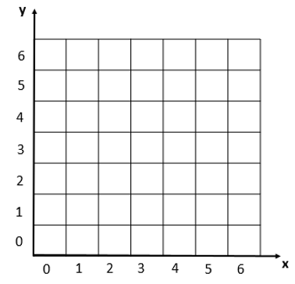

1. (x>2) and not((x>3 and x<4) and (y>2 and y<6))



1. Write the boolean condition for this grid

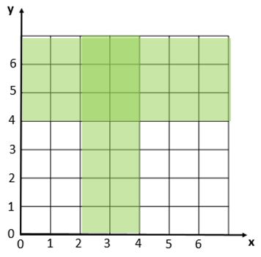

Expression

(x>2 and x<4) and y>4

**Exercise 4: Flowcharts**

1. Draw the tree of conditions

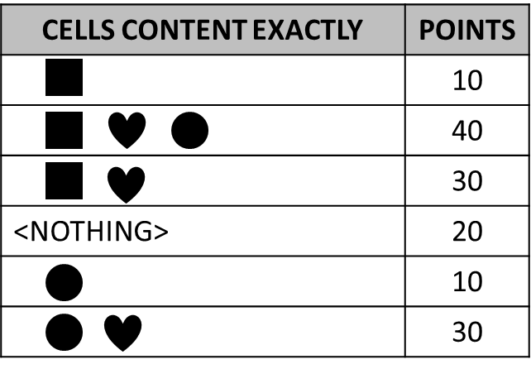

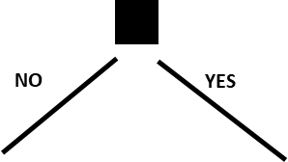

10

10

30

40

20

30

1. Say what I do thanks to the flowchart below?
   1. It is Monday, it’s hot and I have homework. What I do?

It is Monday, it’s hot and I have homework . I do homework.

* 1. It’s Sunday, it’s cold, it’s not raining, I don’t like bicycle and I’m not tired. What I do?

It’s Sunday, it’s cold, it’s not raining, I don’t like bicycle and I’m not tired. I look a movie.

* 1. It’s Friday, it’s cold and raining, I’m tired but I don’t have homework. What I do?

It’s Friday, it’s cold and raining, I’m tired but I don’t have homework. I’m sleepy.

* 1. When do I ride my bike? **Give a boolean expression**

not hot and weeked and not raining I like bicycle.

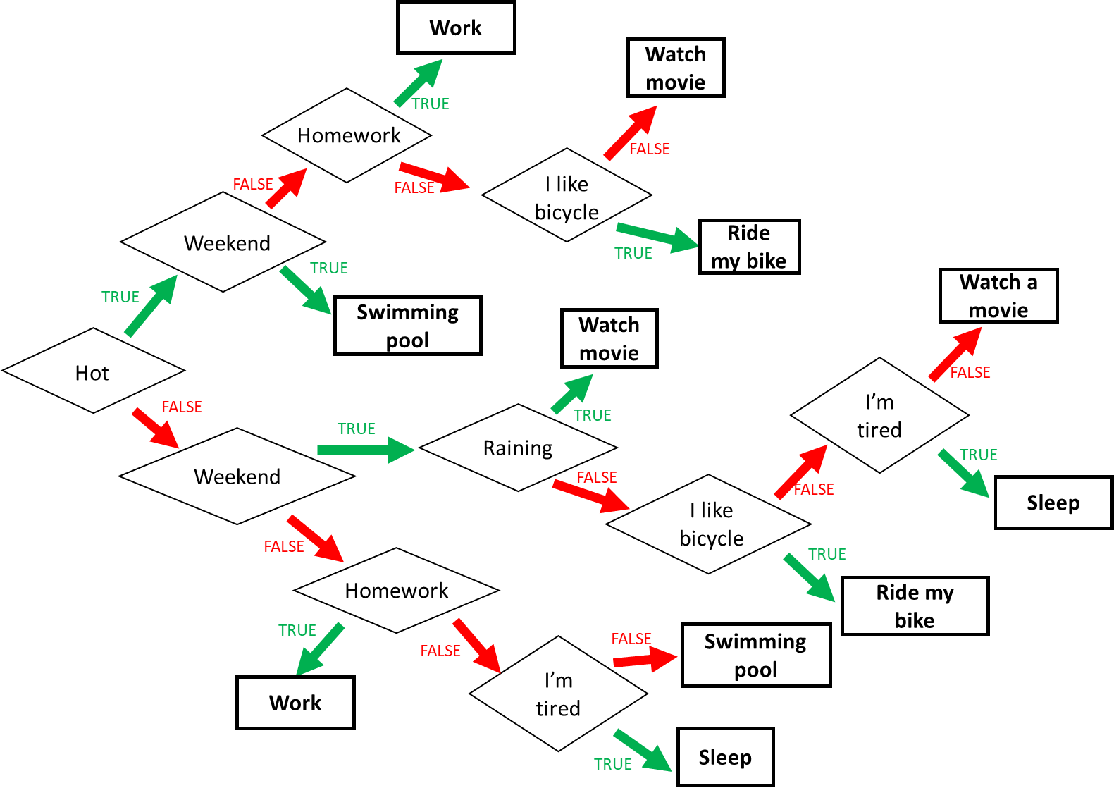

1. Find the boolean expression of **RED** of this flowchart

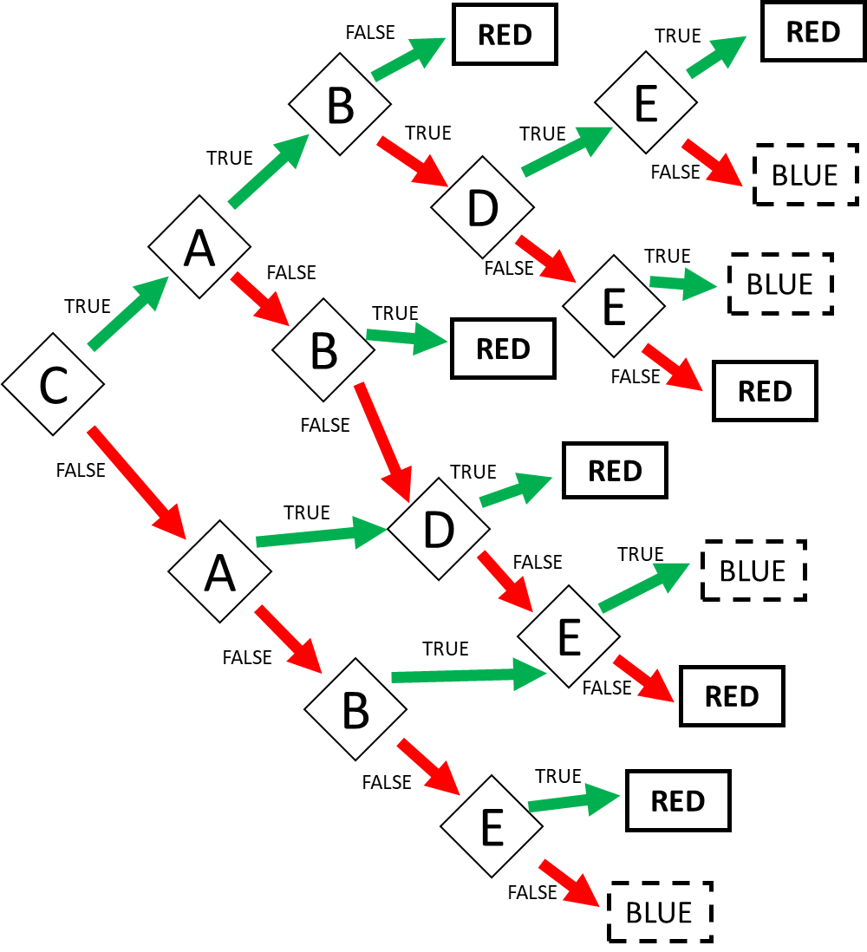

Expression: RED = (cab) or (ca!bde)or (ca!b!d!e) or (c!ab) or (c!a!bd) or (c!a!b!d!e) or (!cad) or (!ca!d!e) or (!c!ab!e) or (!c!a!be)